- Select Login/Registration button

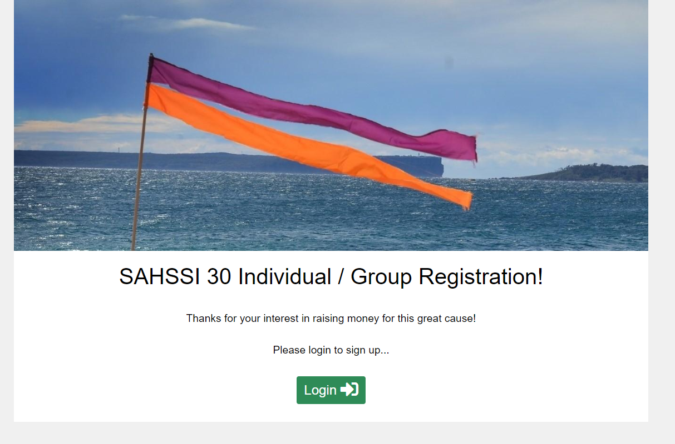
- Participants must register as an individual first.
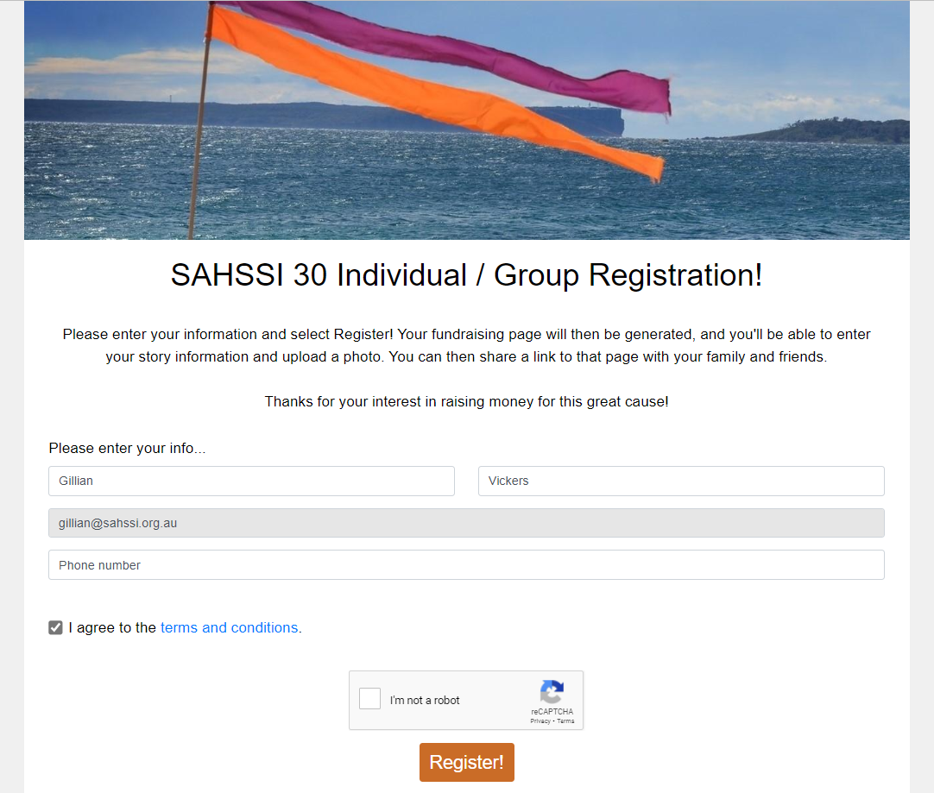

- The following options are available to be edited.
Edit Profile – Participants can add a profile photo and adjust their fundraising target goal.
My Story – Participants can edit their story to explain why you are fundraising.
Teams – Participants can join a registered team or individuals can create a team.
Share – Once you have completed your profile you can ‘Share’ your fundraising page.
